ASSESSMENT OF CULTURAL
HERITAGE SIGNIFICANCE AND
EXECUTIVE DIRECTOR
RECOMMENDATION TO THE
HERITAGE COUNCIL
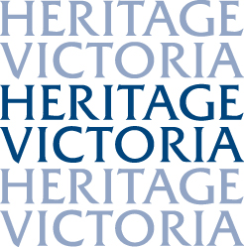

NAME | frogmore
LOCATION | 1 wahgoo Road, carnegie
FILE NUMBER: | FOL/15/5880
HERMES NUMBER: | 197426
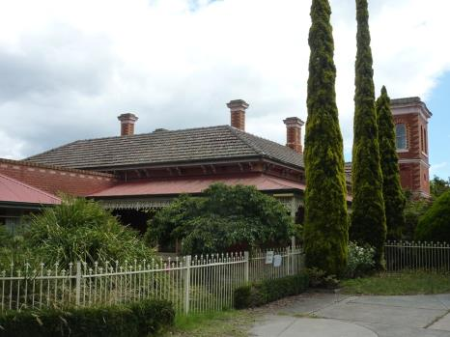
EXECUTIVE DIRECTOR RECOMMENDATION TO THE HERITAGE COUNCIL:
- That the place NOT be included in the Victorian Heritage Register under Section 32 (1)(b) of the Heritage Act 1995.
- The Heritage Council may wish to consider exercising its powers under s42 (1)(d)(i) of the Heritage Act 1995 to refer the recommendation to the Glen Eira Council for consideration of inclusion in the local Heritage Overlay.

TIM SMITH
Executive Director
Recommendation Date: 13 March 2015

NOMINATION
A nomination was accepted by the Executive Director on 21 January 2015.
The nomination was made on the basis that Frogmore satisfies the following Heritage Council criteria for inclusion in the Victorian Heritage Register:

Criterion A
Importance to the course, or pattern, of Victoria’s cultural history.

Criterion B
Possession of uncommon, rare or endangered aspects of Victoria’s cultural history.

Criterion C
Potential to yield information that will contribute to an understanding of Victoria’s cultural history.

Criterion F
Importance in demonstrating a high degree of creative or technical achievement at a particular period.

Criterion G
Strong or special association with a particular community or cultural group for social, cultural or spiritual reasons. This includes the significance of a place to Indigenous peoples as part of their continuing and developing cultural traditions.

Criterion H
Special association with the life or works of a person, or group of persons, of importance in Victoria’s history.

The Executive Director has also deemed it appropriate to assess the place against Criterion D:

Criterion D
Importance in demonstrating the principal characteristics of a class of cultural places and objects.

EXECUTIVE DIRECTOR recommendation reason SUMMARY
It is the view of the Executive Director that Frogmore, Carnegie should not be included in the Victorian Heritage Register (the VHR). After completing an assessment against the Heritage Council’s criteria for inclusion in the VHR, the Executive Director has formed the view that the place does not satisfy the threshold for its inclusion.
The Heritage Council may wish to refer the nomination and any submissions received on the recommendation to the Glen Eira Council for consideration for inclusion of the property within the Heritage Overlay.

RECOMMENDATION REASONS

REASONS FOR NOT RECOMMENDING INCLUSION IN THE VICTORIAN HERITAGE REGISTER [s.34A(2)]
Following is the Executive Director's assessment of the place against the tests set out in The Victorian Heritage Register Criteria and Thresholds Guidelines (2014).

CRITERION A
Importance to the course, or pattern, of Victoria’s cultural history.

Frogmore has been nominated against Criterion A on the basis of its importance as a pastoral property in Victoria and for its links to the pastoralists William Lyall and Archibald McLaurin.

STEP 1: A BASIC TEST FOR SATISFYING CRITERION A
The place/object has a clear ASSOCIATION with an event, phase, period, process, function, movement, custom or way of life in Victoria’s cultural history.
Plus
The association of the place/object to the event, phase, etc IS EVIDENT in the physical fabric of the place/object and/or in documentary resources or oral history.
Plus
The EVENT, PHASE, etc is of HISTORICAL IMPORTANCE, having made a strong or influential contribution to Victoria.

Executive Director’s Response
Frogmore is a small 0.8 hectare remnant of an original 85.8 hectare (212 acre) pastoral holding of William Lyall of the prosperous pastoral partnership of Mickle, Bakewell and Lyall. It holds an association with the establishment of farming properties close to Melbourne, a phase which influenced the development of Victoria. Lyall lived on this property with his family from 1857 to 1868 and occupied a timber house which no longer remains. The association with Lyall is no longer evident in the physical fabric of the place but is well recorded in documentary resources.
Evidence established to date suggests that the present house, known as Frogmore, was built in 1889-90 for Archibald McLaurin. The house therefore has an association with the important land boom period, particularly in Melbourne, and this is evident in the physical fabric of the place.
Criterion A is likely to be satisfied.

STEP 2: A BASIC TEST FOR DETERMINING STATE LEVEL SIGNIFICANCE FOR CRITERION A
The place/object allows the clear association with the event, phase etc. of historical importance to be UNDERSTOOD BETTER THAN MOST OTHER PLACES OR OBJECTS IN VICTORIA WITH SUBSTANTIALLY THE SAME ASSOCIATION.

Executive Director’s Response
The pastoral property on which Frogmore is located was one of many established in Victoria in the mid-nineteenth century. However, like the majority of those large properties located in close proximity to Melbourne, it has been reduced to such an extent that the pastoral use can no longer be clearly understood. By contrast, pastoral properties in country Victoria, such as Glenalbyn Grange, Kingower (VHR H0779), have been retained with substantial acreage to illustrate their former use.
Frogmore is one of a vast number of houses constructed in Melbourne during the boom period, particularly in the late 1880s. Examples are extant throughout many Melbourne suburbs including large numbers in the City of Glen Eira alone. Frogmore does not allow the clear association with the important boom era to be understood any better than a large number of places throughout suburban Melbourne.
Criterion A is not likely to be satisfied at the State level.

CRITERION B
Possession of uncommon, rare or endangered aspects of Victoria’s cultural history.

Frogmore has been nominated against Criterion B on the basis that it possesses uncommon, rare or endangered aspects of Victoria’s cultural history as a rare example of an early Italianate house in Melbourne, surviving from the 1850s, and as a rare example of a farmhouse.

STEP 1: A BASIC TEST FOR SATISFYING CRITERION B
The place/object has a clear ASSOCIATION with an event, phase, period, process, function, movement, custom or way of life of importance in Victoria’s cultural history.
Plus
The association of the place/object to the event, phase, etc IS EVIDENT in the physical fabric of the place/object and/or in documentary resources or oral history.
Plus
The place/object is RARE OR UNCOMMON, being one of a small number of places/objects remaining that demonstrates the important event, phase etc.
OR
The place/object is RARE OR UNCOMMON, containing unusual features of note that were not widely replicated
OR
The existence of the class of place/object that demonstrates the important event, phase etc is ENDANGERED to the point of rarity due to threats and pressures on such places/objects.

Executive Director’s Response
The existing Frogmore house cannot be described as a farmhouse: it is a large house constructed on subdivided land in 1889-90. It is therefore not rare as an example of a farmhouse.
The existing Frogmore house was not built in 1857. Evidence of this has been provided in the following assessment report. The place therefore is not a rare or early example of an Italianate house. As a house built in 1889-90, Frogmore has a direct relationship with the boom period in Melbourne and this is evident in the physical fabric of the place. However the place is neither rare nor uncommon and is one of a vast number of places that reflect this period in Melbourne. It does not contain any unusual features that could be considered rare or uncommon in houses of a similar period.
Criterion B Is not likely to be satisfied.

CRITERION C
Potential to yield information that will contribute to an understanding of Victoria’s cultural history.

Frogmore has been nominated against Criterion C on the basis that it had associations with Scottish culture for over thirty years.

STEP 1: A BASIC TEST FOR SATISFYING CRITERION C
The:
- visible physical fabric; &/or
- documentary evidence; &/or
- oral history,
relating to the place/object indicates a likelihood that the place/object contains PHYSICAL EVIDENCE of historical interest that is NOT CURRENTLY VISIBLE OR UNDERSTOOD.
Plus
From what we know of the place/object,the physical evidence is likely to be of an INTEGRITY and/or CONDITION that it COULD YIELD INFORMATION through detailed investigation.

Executive Director’s Response

The visible physical fabric at Frogmore does not indicate a likelihood that the place contains physical evidence of Scottish heritage that is not currently visible. No documentary or oral history evidence is available which indicates a likelihood that the place contains physical evidence of Scottish cultural heritage that is not currently visible or understood.
Criterion C is not likely to be satisfied.

CRITERION D
Importance in demonstrating the principal characteristics of a class of cultural places and objects.

STEP 1: A BASIC TEST FOR SATISFYING CRITERION D
The place/object is one of a CLASS of places/objects that has a clear ASSOCIATION with an event, phase, period, process, function, movement, important person(s), custom or way of life in Victoria’s history.
Plus
The EVENT, PHASE, etc is of HISTORICAL IMPORTANCE, having made a strong or influential contribution to Victoria.
Plus
The principal characteristics of the class are EVIDENT in the physical fabric of the place/object.

Executive Director’s Response
Evidence established to date suggests that Frogmore was built in 1889-90 and therefore has an association with the Melbourne boom period. This phase was an important and highly influential period in Victoria’s history. Despite the encroachment of later buildings, Frogmore displays the principal characteristics of the Italianate style of the late 1880s.
Criterion D is likely to be satisfied.
STEP 2: A BASIC TEST FOR DETERMINING STATE LEVEL SIGNIFICANCE FOR CRITERION D
The place/object is a NOTABLE EXAMPLE of the class in Victoria (refer to Reference Tool D).

Executive Director’s Response
Frogmore is a fine, but simple, polychromatic Italianate style house which is typical of vast numbers of houses built in a similar period in Victoria. It presents no features that are particularly novel or outstanding in design that would elevate the building to State level significance. Together with a vast number of houses in Victoria, Frogmore is a good – but not notable – representative example of the late 1880s boom style. The plan form is typical, the materials used were commonly employed at the time and the design is standard. The inclusion of a tower is of interest; however it was not an unusual addition to a house built at this time.
Criterion D is not likely to be satisfied at the State level.

Criterion F
Importance in demonstrating a high degree of creative or technical achievement at a particular period.

Frogmore has been nominated against Criterion F on the basis that it demonstrates the diversity of Joseph Reed’s work and demonstrates stock breeding innovations introduced to Victoria by William Lyall.

STEP 1: A BASIC TEST FOR SATISFYING CRITERION F
The place/object contains PHYSICAL EVIDENCE that clearly demonstrates creative or technical ACHIEVEMENT for the time in which it was created.
Plus
The physical evidence demonstrates a HIGH DEGREE OF INTEGRITY.

Executive Director’s Response
Frogmore was not built in 1857 to designs by Joseph Reed during William Lyall’s ownership. This is demonstrated in the following assessment report. The available evidence suggests that Frogmore was designed by Sydney W Smith in 1889-90 and therefore the place does not demonstrate the diversity of the work of Joseph Reed.
William Lyall undertook stock breeding and experimental planting at his property, however the existing building was constructed after his period of occupancy and the remnant land is insufficient in size and remnant agricultural fabric to demonstrate its association with Lyall’s original 85.8 hectare holding. The place does not contain any physical evidence of these practices.
Criterion F is not likely to be satisfied.
CRITERION G
Strong or special association with a particular community or cultural group for social, cultural or spiritual reasons. This includes the significance of a place to indigenous people as part of their continuing and developing cultural traditions.

Frogmore has been nominated against Criterion G on the basis that it has strong links to spiritual meetings and church services.

STEP 1: A BASIC TEST FOR SATISFYING CRITERION G
Evidence exists of a DIRECT ASSOCIATION between the place/object and a PARTICULAR COMMUNITY OR CULTURAL GROUP.
(For the purpose of these guidelines, ‘COMMUNITY or CULTURAL GROUP’ is defined as a sizable group of persons who share a common and long-standing interest or identity).
Plus
The association between the place/object and the community or cultural group is STRONG OR SPECIAL, as evidenced by the regular or long-term use of/engagement with the place/object or the enduring ceremonial, ritual, commemorative, spiritual or celebratory use of the place/object.

Executive Director’s Response
Although owned by a group with religious affiliations, no evidence has been provided to indicate strong links between the place and a particular religious community.
Criterion G is not likely to be satisfied.
CRITERION H
Special association with the life or works of a person, or group of persons, of importance in Victoria’s history.

Frogmore has been nominated against Criterion H on the basis of its links to William Lyall and Archibald McLaurin.

STEP 1: A BASIC TEST FOR SATISFYING CRITERION H
The place/object has a DIRECT ASSOCIATION with a person or group of persons who have made a strong or influential CONTRIBUTION to the course of Victoria’s history.
Plus
The association of the place/object to the person(s) IS EVIDENT in the physical fabric of the place/object and/or in documentary resources and/or oral history.
Plus
The ASSOCIATION:
- directly relates to ACHIEVEMENTS of the person(s) at, or relating to, the place/object; or
- relates to an enduring and/or close INTERACTION between the person(s) and the place/object.

Executive Director’s Response
The available evidence suggests that the existing Frogmore house appears to have been built for Archibald McLaurin in 1889-90, twenty years after he purchased the Frogmore property from William Lyall. The land on which Frogmore is located has an association with William Lyall who owned and lived at the property (in a different house) from 1857 to 1868 and used it for breeding stock and farming. Together with partners Mickle and Bakewell, William Lyall was a prosperous pastoralist who took up several pastoral runs in Victoria. Lyall was to become a well known pastoralist, farmer, stock and horse breeder, parliamentarian, local councillor and acclimatisation enthusiast in Victoria. Many of these roles were undertaken while residing on land that now contains Frogmore. Although not evident in the physical fabric of the place, documentary sources clearly confirm this association with the place.
The property has a direct association with pastoralist Archibald McLaurin, who owned and lived at the property from 1868 until his death in 1891. McLaurin is noted as one of the first overlanders, grazing the area that became Brighton and subsequently leasing Mordialloc Station. Joining his brother, he amassed a large number of southern Riverina properties before moving to Frogmore at the age of 53, where he continued his pastoral interests. McLaurin was active in the community and was a Caulfield Shire Councillor. Documentary sources confirm this association.
Frogmore is an early design by Melbourne architect Sydney W Smith. The partnership of Sydney Smith & Ogg, formed in 1889, made an important contribution to architecture in the state with Art Nouveau-inspired design from 1901, including Milton House (1901, VHR H0582), the State Savings Bank, Yarraville (1909, VHR H0723) and hotel designs, including the Prince Albert Hotel, Williamstown (1915-16, VHR H1793).
Criterion H is likely to be satisfied.

STEP 2: A BASIC TEST FOR DETERMINING STATE LEVEL SIGNIFICANCE FOR CRITERION H
The place/object allows the clear association with the person or group of persons to be READILY APPRECIATED BETTER THAN MOST OTHER PLACES OR OBJECTS IN VICTORIA.

Executive Director’s Response
William Lyall and his family lived at Tooradin in the Western Port Bay district in 1852-53 and returned to live in the area after leaving the Frogmore property. Lyall maintained ownership of property at Tooradin while living at Frogmore and used the property for additional stock breeding and experimental planting. Lyall’s passion for the Western Port Bay district attracted him back to Tooradin and in 1868 the family moved permanently to Harewood (VHR H0284), which was built for Lyall. William Lyall continued to live there for twenty years until his death in 1888 and the property subsequently remained in the Lyall family until the 1960s.
Harewood, Tooradin is included in the VHR and is considered to have strong associations with the pastoralist, William Lyall. These associations are appreciated expressed at Harewood than at Frogmore.
Archibald McLaurin was active in the community and was a Caulfield Shire Councillor. Documentary sources demonstrate his strong contribution at a local level; however insufficient evidence is available to demonstrate that McLaurin made a strong or influential contribution to the course of Victoria’s history.
Frogmore is an early design by Melbourne architect Sydney W Smith. Smith’s work is well-represented in the VHR. Frogmore is not an outstanding or notable example of Smith’s work.
Criterion H is not likely to be satisfied at the State level.

ASSESSMENT OF CULTURAL HERITAGE SIGNIFICANCE
EXECUTIVE DIRECTOR’S ASSESSMENT OF CULTURAL HERITAGE SIGNIFICANCE [s.34A(2)(d)]
Frogmore, Carnegie is not of sufficient cultural heritage significance to be included in the Victorian Heritage Register.

DESCRIPTION
Frogmore is a single storey late Victorian Italianate brick house with hipped tiled roof, surrounding verandah and adjoining tower to the east. It contains six main rooms placed either side of a central passage, a cross hall leading to tower stairs, two rear rooms and a modified service wing to the rear. A number of later buildings, added as the place was developed as an aged care facility, encroach upon the house. The exterior of the north portion of the house in particular has been obscured, however the form of the main section of the original place remains largely intact at the core of the developed facility.
Built of red brick, contrasting cream brick has been used as quoining at the corners of the building, tower and chimneys and to highlight window and door openings. The main entrance has been obscured by an addition to the front of the house, however the opening remains flanked by two polygonal bay windows. Cast iron verandah detailing to the east of this central addition, and along the east facade of the house, has been replaced with later decorative frieze, brackets and columns. Original cast iron verandah columns, with makers plate ‘Cochrane and Scott, Makers, Melbourne’, remain to the west of the addition, however friezes and brackets have been removed. Pairs of timber consoles line the eaves of the house and five dichromatic chimneys with render detailing remain. Three full length window openings on either side of the house provide direct access from the front six rooms to the surrounding verandah.
The brick tower, with a plain crowning cornice, is divided into three sections by stringcourses. The lower section contains single arched openings, the middle level contains a bulls eye window on the east side and the upper level contains pairs of arch headed windows. Corners of the tower incorporate a distinctive and more complex cream brick pattern from that of the body of the house. A later single storey building abuts the east side of the tower.
The interior of the house retains some original decoration, including pilasters with arches, a corbelled arch, plain cornices and stair balustrading. The tower, with viewing platform, remains accessible.

RELEVANT INFORMATION
Local Government Authority | Glen Eira
HERITAGE LISTING INFORMATION
- Heritage Overlay: | No – interim Heritage Overlay control requested
- Other listing: | No

HISTORY

History of the Frogmore Property

The present Frogmore house is situated on the northern boundary of Crown Allotment 76 in the Parish of Prahran, which was purchased by J Mickle and J Bakewell in 1853. This allotment was located in the eastern section of the parish, between the present Koornang and Murrumbeena Roads. Mickle and Bakewell sold Crown Allotment 76 to the third member of their prosperous pastoral partnership, William Lyall, in 1854 and within the next four years Lyall had acquired part of the allotment to the north, CP5A, and two allotments east of Murrumbeena Road, CP77 and CP78. By 1859 his total holding at Frogmore, Murrumbeena was 85.8 hectares (212 acres). On this property Lyall built a 5-roomed timber house in c1857 and his family resided at the property until 1868. The location of this timber house, which remained until at least 1863, has not been determined.
In October 1856 architect Joseph Reed called tenders for an ‘Italian villa residence’ to be erected for William Lyall near St Kilda. For a number of years it has been assumed that this was the existing brick house known as Frogmore, however this is not the case. Available Rate Books clearly record the presence of a timber house from 1858 until at least 1863. William Lyall had other land holdings in the St Kilda area, including eight acres at the corner of Balaclava and Orrong Roads which he owned from 1853 to 1859 (the site of the present house, Labassa). This tender may have referred to a house built on another of his properties.

William Lyall bred cattle, sheep and horses at the Frogmore property after returning from a trip to England and Scotland in 1856 and settling at the property. He imported Hereford cattle, Cotswold sheep, Shetland ponies, Romney Marsh sheep and thoroughbred horses, and used this and other properties for breeding and experimenting with various plants. Lyall was to become a well known pastoralist, farmer, stock and horse breeder, parliamentarian, local councillor and acclimatisation enthusiast in Victoria.

The Mickle, Bakewell and Lyall partnership acquired large land holdings in Victoria in the 1850s, particularly in the Western Port region, and it was to a newly built house named Harewood at Tooradin that Lyall and his family moved in May 1868. At this time Lyall sold the 85.8 hectare Frogmore property to another well known pastoralist, Archibald McLaurin who continued stock breeding activity at the property. Like Lyall, McLaurin became involved in local affairs, as a Caulfield Road District Board member in 1869 and local councillor in the 1870s.

Accessible Rate Books indicate that by 1871 McLaurin owned an 8-roomed brick house on 73.6 hectares (182 acres) at Frogmore. The location and date of construction of this house have not been established, however it was built between 1863 and 1871. In c1887 McLaurin’s property was reduced in size to 37.2 hectares (92 acres) reflecting his subdivision and sale of land at the height of the boom period in Melbourne. Rate Books record that he also held an additional 12 hectares (30 acres) which may have adjoined the larger allotment. One land sale, described as the ‘second subdivisional sale of the Murrumbeena Estate’, was advertised in the Argus in October 1888. Land sold at this time comprised largely of property to the east of Murrumbeena Road.

There are many indications that Archibald McLaurin had a new house constructed at Frogmore in 1889-90, following subdivision of his property. These include:

- McLaurin’s brick house (without land) on the 37.2 hectare allotment was valued at £60 in the Rate Book of 1888/89. By 1890 a ten roomed brick house on the same allotment was valued at £250 (again without land).
- A written description in the 1889 Rate Book refers to the house on McLaurin’s 37.2 hectare property ‘being pulled down’.
- There are records relating to the acceptance of tenders by Sydney W Smith in June 1889 for erection of a brick villa residence for A McLaurin at Murrumbeena [Building Engineering and Mining Journal, 22 June 1889, s p 3]
- There are records relating to the calling for tenders from bricklayers for a ‘large villa with tower for Archibald McLaurin, Frogmore, Murrumbeena, near station’, by J Wickson [Argus 4 November 1889, p 3]. These tenders were presumably called by the successful tenderer, possibly James Dickson, a known Melbourne builder, rather than J Wickson. Coincidently Rate Books list Dickson as the owner of 19 properties, east of Murrumbeena Road in 1888, and on his death in 1901 he had retained ownership of part of CP77, fronting Murrumbeena Road. [Wills & Probate records, PROV].

McLaurin died in 1891 and Frogmore was advertised for let in the Argus 19 July 1899, p 3. At this time it was described as a handsome villa of 10 rooms with offices, stabling and complete outbuildings, garden, orchard on 6.5 hectares (16 acres) or 50.6 hectares (125 acres). A similar advertisement described the property as 4 hectares (10 acres) in 1904.

Brighton doctor, Adolph Frederic Seelenmeyer, acquired over 46.9 hectares (116 acres) of the northern section of the remaining Frogmore estate in 1911. He undertook further subdivision and sold the 1.6 hectare (4 acre) house lot to John G Thompson in 1912. Thompson undertook his own subdivision of the remaining house lot while living at Frogmore (renamed Hethersett as indicated on some plans) by forming the J G Thompson Estate which was offered for sale in 1917. This comprised thirteen building allotments to the west and south of the existing house.

Ludbrook Menck, manufacturer and stock breeder, acquired Frogmore house in 1920 and charity events held there during his occupancy were reported in the press at the time. The property was sold to the Keys family in 1924 and remained in their ownership until 1946 when it was purchased by the Church of Christ in Victoria for conversion into a hospital. The surrounding 0.8 hectare (2 acre) property provided the opportunity to construct additional wards and associated buildings. Major additions were made in 1949 (since demolished), 1966 and 1990 however the original house has been retained as the core of the developed facility.

Additional evidence for dating the place
In addition to historical information provided, there are physical and architectural characteristics that confirm that the house was not built in 1857. These include:

- The earliest example of fully developed polychromatic brickwork identified in Victoria, and possibly Australia, appears to be All Saints/St Margaret’s Anglican Church, Eltham (1861-62) by Nathaniel Billing. The best known examples in Victoria are also amongst the earliest, these being the churches and houses erected in Melbourne in the 1860s by Joseph Reed after his return from a trip to Europe in 1864 where he viewed medieval brick architecture. Polychromatic houses include Canally, East Melbourne (1864), Euro-Reko, St Kilda (1865) and Ripponlea (1868) and churches include St Jude’s, Carlton (1866-70) and the former Independent Church, Collins Street (1867).
- Original cast iron verandah columns have been retained at the south-west corner of the house. The corner column retains a makers mark which reads ‘Cochrane & Scott. Makers. Melbourne’. This prolific firm of Melbourne iron makers was established in 1879 and continued production for a number of years. [R A Vowells. Victoria’s Iron Lacework. The Founders, Part A, Parkville 2012]
- Decorative cast ironwork, evident in an early photograph of the house, was not available in the late 1850s. In fact even in the 1870s ironwork designs were simple and often geometric and tended to feature open, less intricate patterns. The production of decorative cast ironwork peaked in the late 1880s with large numbers of new designs registered by local foundries in 1886 and 1887. This coincided with the boom years in Melbourne and the subsequent extravagant residential design of large numbers of houses.

Architect of Frogmore, Sydney Wigham Smith
The architect of Frogmore, Sydney Wigham Smith, learnt his profession from his father, Sydney William Smith, who was responsible for the design of a number of buildings as engineer and municipal surveyor in suburban Melbourne, including the Caulfield Town Hall. After the death of his father in 1886, Sydney Wigham Smith continued his business and produced a considerable amount of work, including houses, shops, hotels and commercial buildings. He formed the partnership Sydney Smith & Ogg with Charles Ogg in 1889 and this firm became best known for their Art Nouveau-inspired work in the early twentieth century, such as Milton House (1901, VHR H0582) and the State Savings Bank, Yarraville (1909, VHR H0723) and hotel designs, including the Prince Albert Hotel, Williamstown (1915-16, VHR H1793).
Frogmore was one of a number of houses for which Sydney W Smith called tenders between 1886 and 1889.

Construction details
Architect name: Sydney Wigham Smith
Architectural style name: Italianate
Builder name: J Dickson?
Construction started date: 1889-90

VICTORIAN HISTORICAL THEMES
04 Transforming and managing land and natural resources
4.4 Farming
06 Building towns, cities and the garden state
6.7 Making homes for Victorians

INTEGRITY/INTACTNESS
Frogmore retains much of its original fabric however later building development surrounds the original house, reducing its integrity. Additions made to each side of the building have generally resulted in minimal interference with the existing fabric. As a result, the original form of the place is discernible from the surviving fabric.
The original roof slates have been replaced with glazed tiles, gutters have been replaced, verandah floors have been concreted and the decorative cast ironwork of the eastern facade has been replaced with more recent aluminium frieze and brackets. Internally all fireplaces have been blocked, dado wall panelling and handrails inserted and some of the features, such as architraves, may have been replaced. (February 2015)

CONDITION
The place is generally in good condition with the redevelopment of the building into an aged care facility resulting in a high level of maintenance of the fabric. The brickwork is in excellent condition with no cracking evident. Interior finishes of the upper level of the tower are in poor condition. (February 2015)

COMPARISONS

Late 1880s/early 1890s Italianate houses included in the VHR
The Italianate style is commonly characterised by asymmetrical massing, low hipped roofs, eaves elaborated by classical detail and plain stuccoed walls. These characteristics were evident as early as the 1850s and continued to the end of the nineteenth century, with an increase in the use of exposed brickwork and the associated introduction of polychromatic brickwork, as well as the introduction of such decorative features as cast iron lacework. These innovations became increasingly popular in the 1870s, 1880s and early 1890s and can be seen in vast numbers of large and small suburban houses throughout Melbourne.

There are numerous examples of Italianate houses from the late 1880s listed in the VHR. These are included for their notable architectural significance and/or for significant historical associations. Many of these are large and distinctive houses from this period.

1. Single storey houses built in the late 1880s/early 1890s

Lord Lodge, Caulfield East (VHR H0071)
Lord Lodge is a thoroughbred racehorse training complex adjacent to Caulfield Racecourse, established in 1890. The area immediately around the racecourse has been associated with horse racing activities and businesses servicing the industry since the development of the racecourse in late the 19th century. A single storey brick Italianate villa, with asymmetrical facade, faceted bay window and prominent central tower is part of the complex. The complex is of historical significance as a rare example of a late nineteenth century metropolitan racehorse training facility and of architectural significance as a substantially intact group of buildings which retain original features and fabric. The villa itself is highly representative of Italianate or Boom period architecture albeit a relatively modest form when compared to a large number of examples.

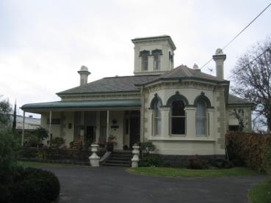 Lord Lodge Villa, Caulfield East (VHR H0071)

Clowance, Golden Point VHR H1898
Clowance was built in 1892-93 to the design of local architect WE Gribble and has architectural significance as an innovative and intact example of a transitional style between Victorian Italianate and Federation Queen Anne. It is a single storey brick bichromatic building, Italianate in form, with asymmetrical facade, a patterned hipped slate roof and unusually detailed Tudor style chimneys and projecting, rendered bay windows, one with a battlemented parapet and another with a raised pediment. The interior of the house is also notable with timber detailing, marbling, frescoes, leadlight door surrounds, woodgraining, marble fire surrounds and a variety of decorative ceilings including coved, papier mâché and rattan ceilings.

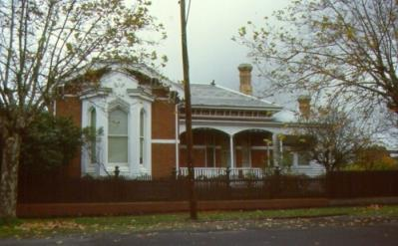 Clowance, Golden Point (VHR H1898)

2. Two storey houses built in the late 1880s/early 1890s
There are a large number of two storey houses of this period included in the VHR. These include polychromatic examples such as Deloraine Terrace and Rippon Lea.
Deloraine Terrace, 499-507 Royal Pde, Parkville (VHR H0098)
Deloraine Terrace was built in 1886-87 as a row of five terrace houses which give the appearance of an imposing single residence. Surrounded by grand single houses along Royal Parade, this terrace is of architectural significance as an exceptionally fine, elaborate and unusual example of a late Victorian polychromatic brick terrace.
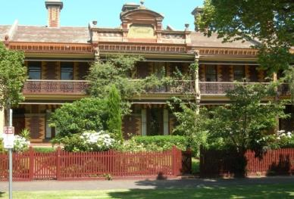 Deloraine Terrace, Parkville (VHR H0098)

Rippon Lea, Elsternwick (VHR H0614)
The core of the house at the Rippon Lea estate was built for Frederick Sargood in 1868 to designs by architect Joseph Reed. Further additions were made in the 1880s and into the twentieth century. It is of significance as one of the largest and most intact estates in Victoria, developed by prominent Victorian businessman and politician, Frederick Sargood, over a period of thirty-five years and of architectural significance as one of the finest extant domestic examples of polychromy by Joseph Reed.
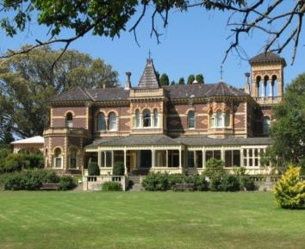 Rippon Lea, Elsternwick (VHR H0614)

The following houses are examples of large houses included on the VHR as representative examples of their style and their associations with the Melbourne boom period:
Cullymont & Eyre Court, Canterbury (1890, VHR H0811) which has additional significance as an unusual pair of integrated buildings.
Frognall, Canterbury (1888-89, VHR H0707) which has additional significance for the retention of original outbuildings and stables.
Wardlow, Parkville (1888, VHR H1922) which has additional significance for its fine and intact interiors.
Labassa, Caulfield (1890 remodelling of 1862 & 1873 house, VHR H0135) which has additional significance as a prominent example of the French Renaissance style with German overtones, for its outstanding interior decoration and as the most important work of the architect J A B Koch in Victoria.
Comparison to nominated place

As a simple, and largely typical, Italianate style house from the late 1880s, Frogmore does not present any features that are particularly novel or outstanding in design that would elevate the building to State level significance. Together with a large number of houses in Victoria, Frogmore is a good representative example of the late 1880s boom style. The plan form, interior decoration and materials used are typical of the period. The inclusion of a tower and the use of polychromatic brickwork are of interest however neither were uncommon in residential work at the time.

Late 1880s Italianate houses not included in the VHR but included in the City of Glen Eira Planning Scheme Heritage Overlay
A number of houses included in the local heritage overlay provide comparison with Frogmore. These include two storey houses at 11, 12 and 15 Gladstone Parade, Elsternwick which were built using polychromatic brickwork in 1888-89. These are all substantial houses which appear to retain a high degree of integrity. A fourth house, built in 1890 and located at 225 North Road, Caulfield incorporates a substantial tower and polygonal corner bay with pyramidal roof.
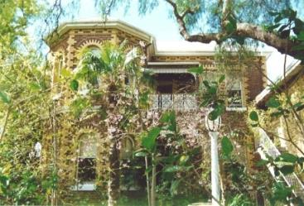 11 Gladstone Parade, Elsternwick (HO22)

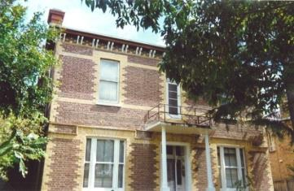 12 Gladstone Parade, Elsternwick (HO22)

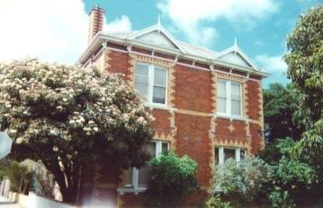 15 Gladstone Parade, Elsternwick (HO22)
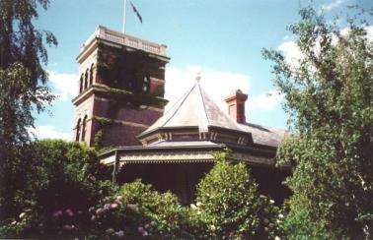 225 North Road, Caulfield (HO49)

Comparison to nominated place
Frogmore exhibits characteristics that are consistent with a number of other examples in the City of Glen Eira Heritage Overlay. Many other suburban municipalities contain similar examples of houses built at a similar time to Frogmore. This demonstrates that a vast array of examples of similar houses remain in the State of Victoria.

Work of architect Sydney Wigham Smith
Sydney Wigham Smith designed a diverse range of buildings including hotels, banks, houses, shops and churches. Smith made his most notable contribution to architecture in Victoria in the partnership Sydney Smith & Ogg, with Art Nouveau-derived designs in the early twentieth century, including Milton House, Flinders Lane, Melbourne in 1901 (VHR H0582), a number of State Savings Banks including that at Yarraville in 1909 (VHR H0723) and a number of hotels including the Prince Albert Hotel, Williamstown (1915-16, VHR H1793).
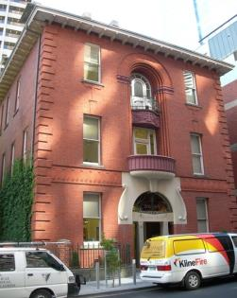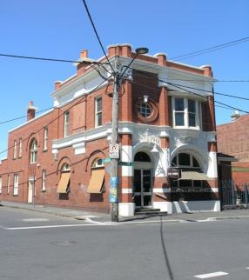
Milton House, Flinders Lane, Melbourne, 1901 (VHR H0582) & S S Bank, Yarraville, 1909 (VHR H0723)

Comparison to nominated place
Frogmore is an early example of Smith’s work and is of interesting, but not notable, design.

KEY REFERENCES USED TO PREPARE ASSESSMENT
City of Caulfield Rate Books, 1858-63, 1871-92, Public Records Office Victoria
Various newspaper and journal references from 1857 onwards
Various diaries, letters and transcripts of William Lyall, State Library of Victoria
Mary G Lyall Davis. William Lyall of ‘Harewood’. A family history. Yarra Glen 1993
Peter Murray & John Wells. From Sand, Swamp and Heath...a History of Caulfield. Caulfield 1980
Graeme Butler & Associates Heritage Assessment of Frogmore for City of Glen Eira, 2015
ADDITIONAL IMAGES/MAPS

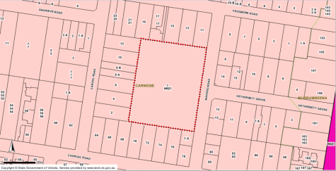
Map showing location of Frogmore.
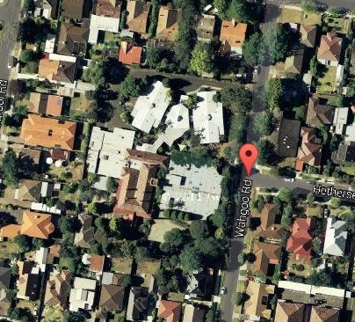
Aerial photograph of Frogmore, showing building development surrounding the original house.
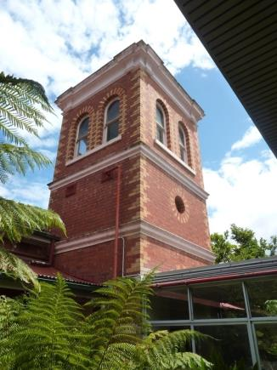
Detail of tower.

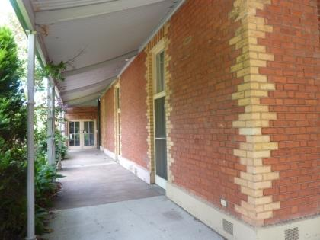
Detail of western wall of main house, with original verandah columns.
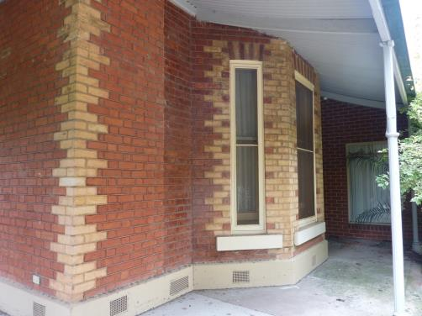
Detail of polygonal bay and polychromatic brickwork.

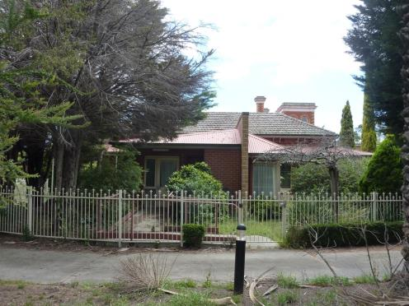
South elevation showing c1990s addition to front of the original house.
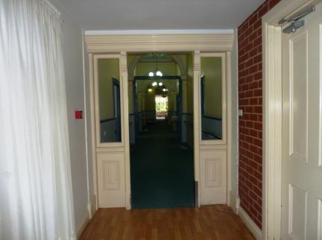
Detail of original front entrance of house, contained within c1990s addition.

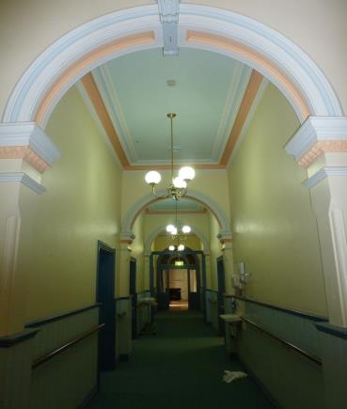
View to front entrance.

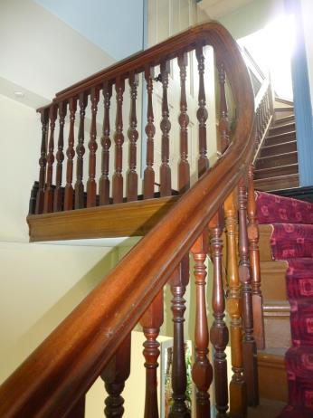
Detail of stair to tower.
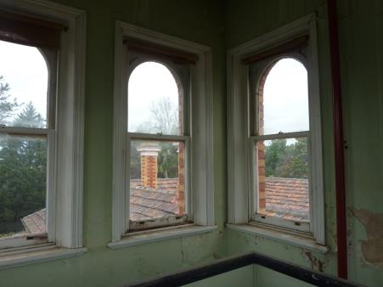
View to south from tower.
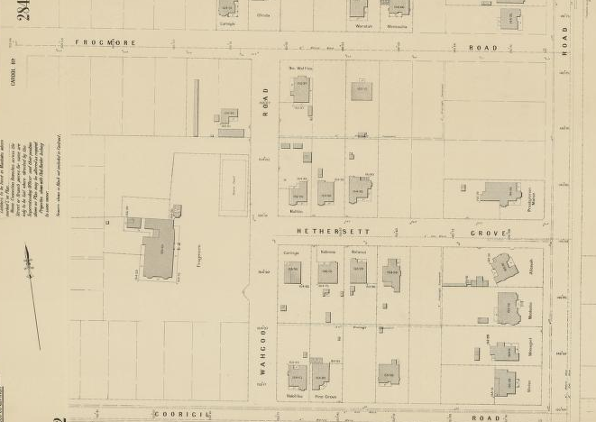
MMBW detail plan 2853 (1919) showing remaining allotment with Frogmore house.

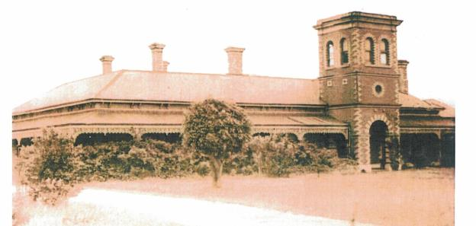
Photograph of Frogmore from c1920s.

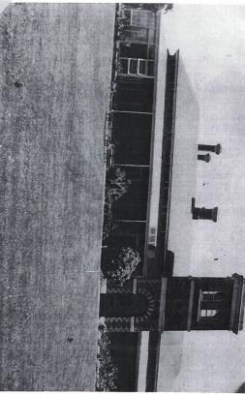
Photograph of Frogmore from c1950s
Note the removal of iron lacework from verandah and glazed southern corner of verandah.

